**YouSaveOurWorld Whitepaper**

**Written by the Editorial team at YouSaveOurWorld**

**Date: 25 April 2025**

# **Sustainable Living in 2025: Global Trends, Statistics, and Future Outlook**

## **Introduction**

As the world confronts the accelerating impacts of climate change, resource depletion, and environmental degradation, the concept of sustainable living has transitioned from a niche aspiration to an essential strategy for individuals, corporations, and governments alike. In 2025, sustainability is propelled by breakthrough technologies, robust policy frameworks, and a marked shift in consumer values. This whitepaper offers a thorough, third-person analysis of today’s sustainable living landscape, synthesizing key data points, highlighting emerging innovations, and projecting future trajectories that will define our collective path toward environmental resilience and social equity.

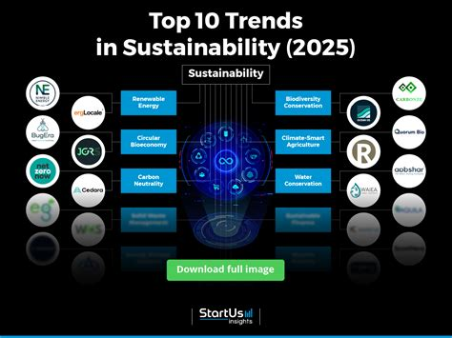

## **The Global Imperative for Sustainable Living**

The urgency of adopting sustainable practices is underscored by stark environmental indicators. Nearly half of the global population endures severe water scarcity for at least part of each year, and projections indicate that by 2025 some 1.8 billion people will experience absolute water scarcity (<https://en.wikipedia.org/wiki/Water_scarcity>). Meanwhile, rising greenhouse gas emissions threaten to push average temperatures beyond critical thresholds, demanding coordinated mitigation and adaptation strategies.

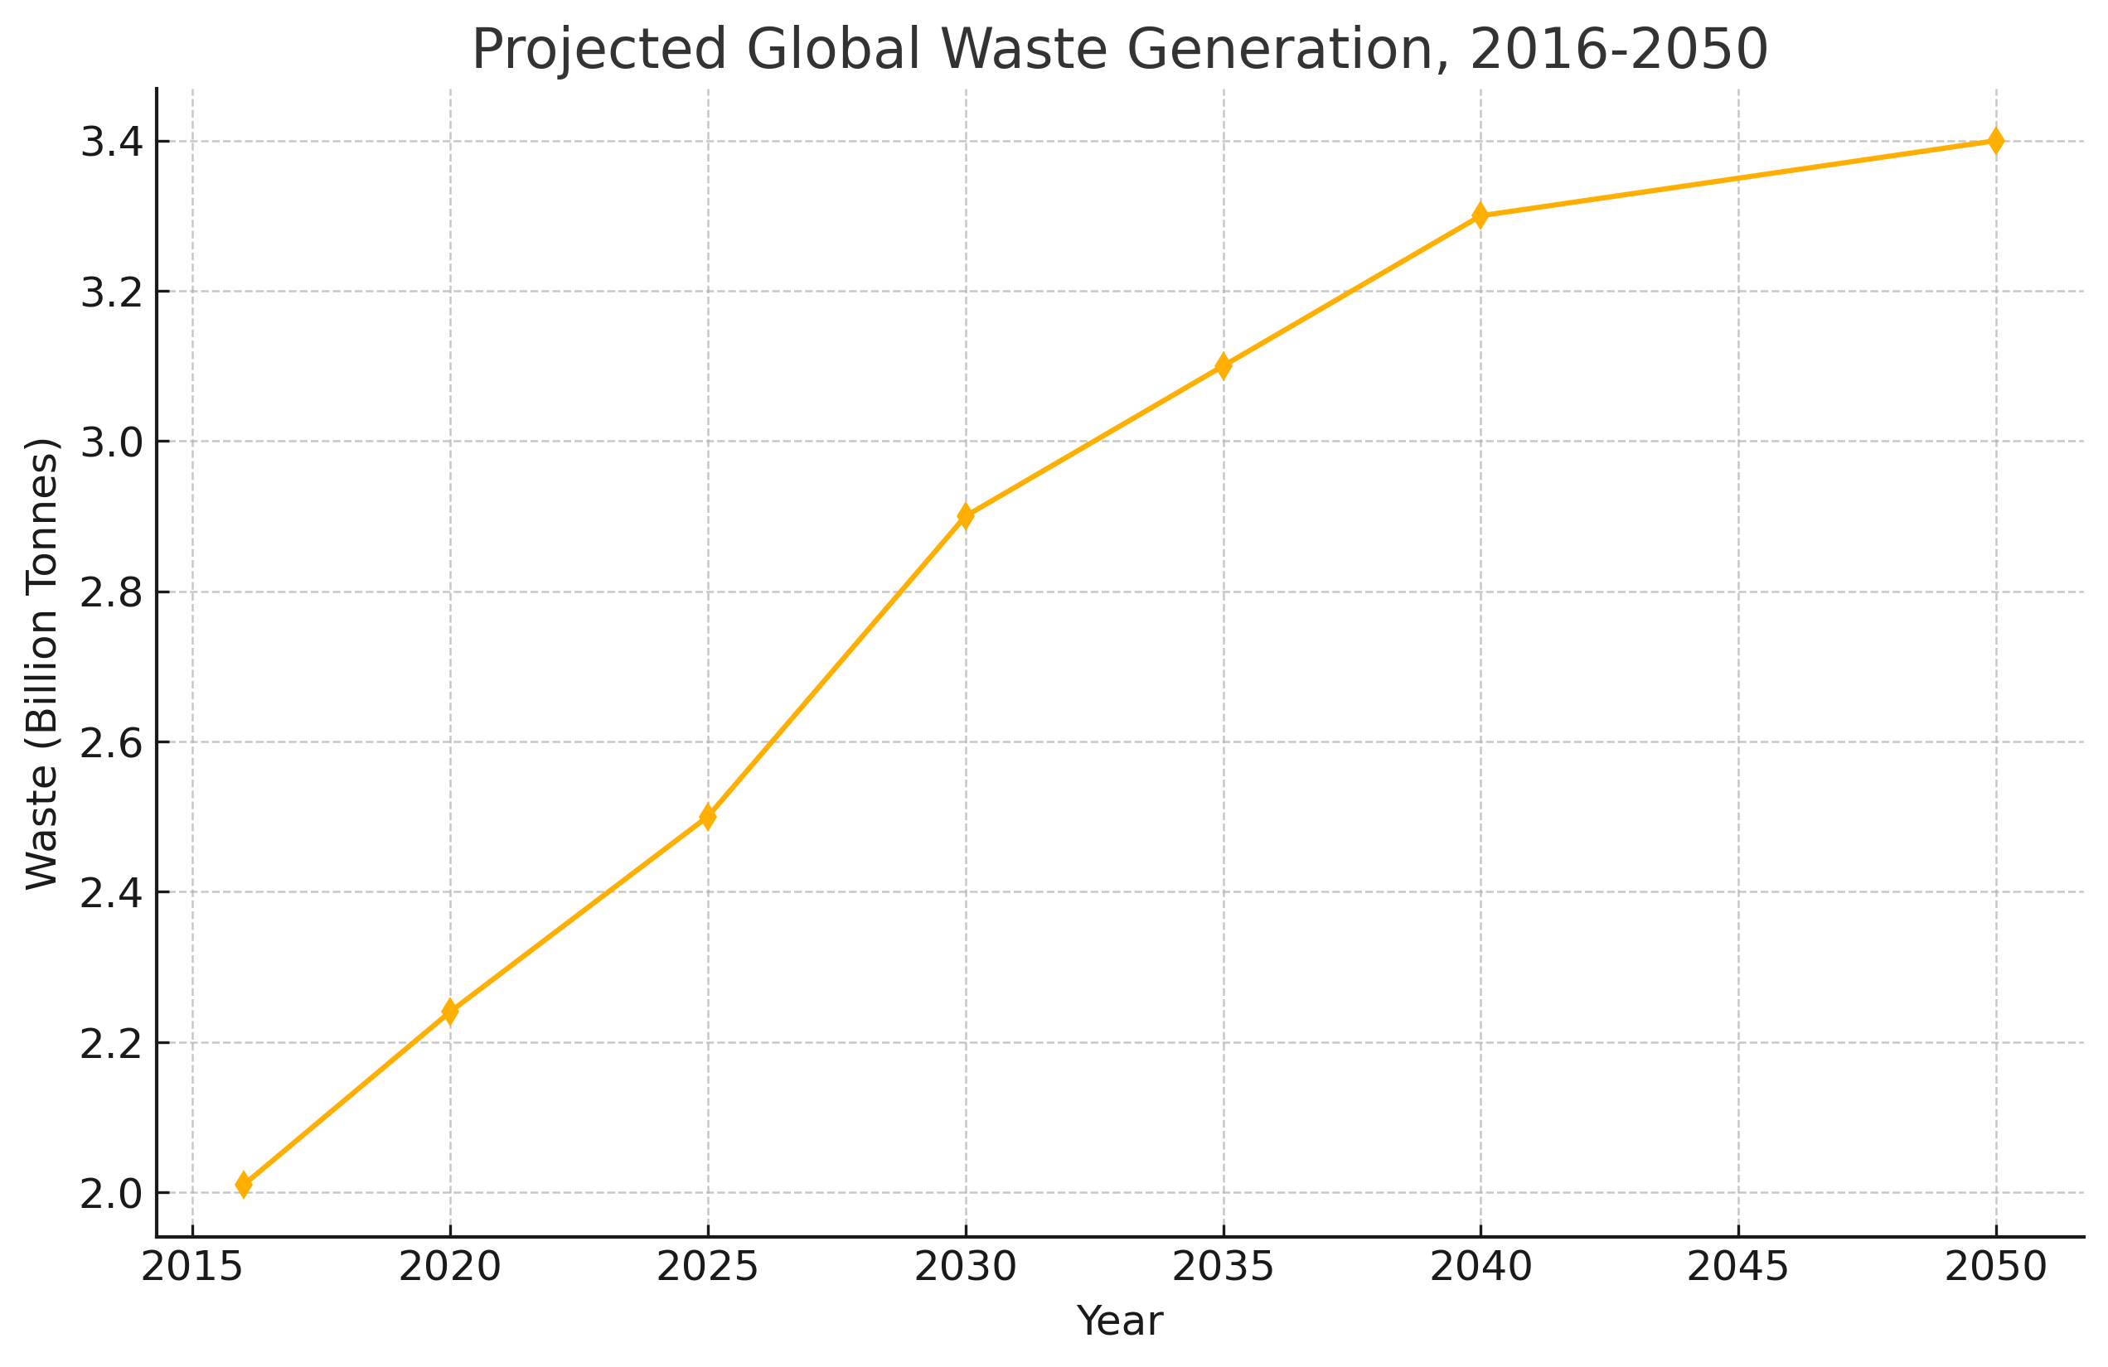

Regulatory measures are responding in kind. The European Union’s Corporate Sustainability Reporting Directive (CSRD) now mandates that large companies publish detailed accounts of their environmental, social, and governance (ESG) impacts (<https://impact.economist.com/sustainability/net-zero-and-energy/sustainability-trends-for-2025>). By enforcing transparency and accountability, such policies aim to realign corporate behavior with global climate objectives.

## **Consumer Behavior and Sustainable Choices**

Consumer preferences in 2025 increasingly reflect environmental consciousness. Surveys show that 72 percent of global consumers are willing to pay a premium for products verified as sustainable (<https://www.arbor.eco/blog/sustainability-statistics>). This willingness is especially pronounced among Gen Z and Millennial cohorts, whose purchasing decisions often hinge on ethical sourcing and minimal environmental impact.

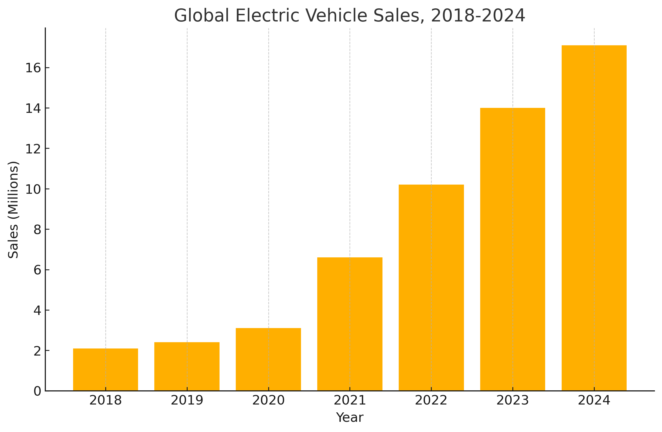

In the food sector, plant-based alternatives and regenerative agricultural methods are gaining traction, driving down carbon footprints and conserving biodiversity (<https://www.theguardian.com/journey-to-greener-groceries/2025/feb/12/lentil-pasta-veg-ready-meals-how-your-shopping-basket-is-becoming-healthier-and-more-sustainable>). Concurrently, the fashion industry is witnessing robust demand for garments produced through circular-economy principles—favoring reuse, repair, and recycling over disposable fast fashion.

## **Technological Innovations Driving Sustainability**

Cutting-edge technologies are pivotal in advancing sustainable living. The global green technology and sustainability market, valued at USD 25.47 billion in 2025, is anticipated to surge to USD 73.9 billion by 2030, fueled by developments in artificial intelligence, blockchain, and cloud computing (<https://www.globenewswire.com/news-release/2025/03/20/3046392/28124/en/Green-Technology-Sustainability-Market-Report-2025-Global-Green-Tech-Market-to-Skyrocket-to-73-9-Billion-by-2030-Driven-by-AI-ESG-Compliance.html>). AI-powered energy management systems enable real-time optimization of grid loads, while blockchain applications enhance supply-chain transparency, ensuring that raw materials are sourced ethically and responsibly.

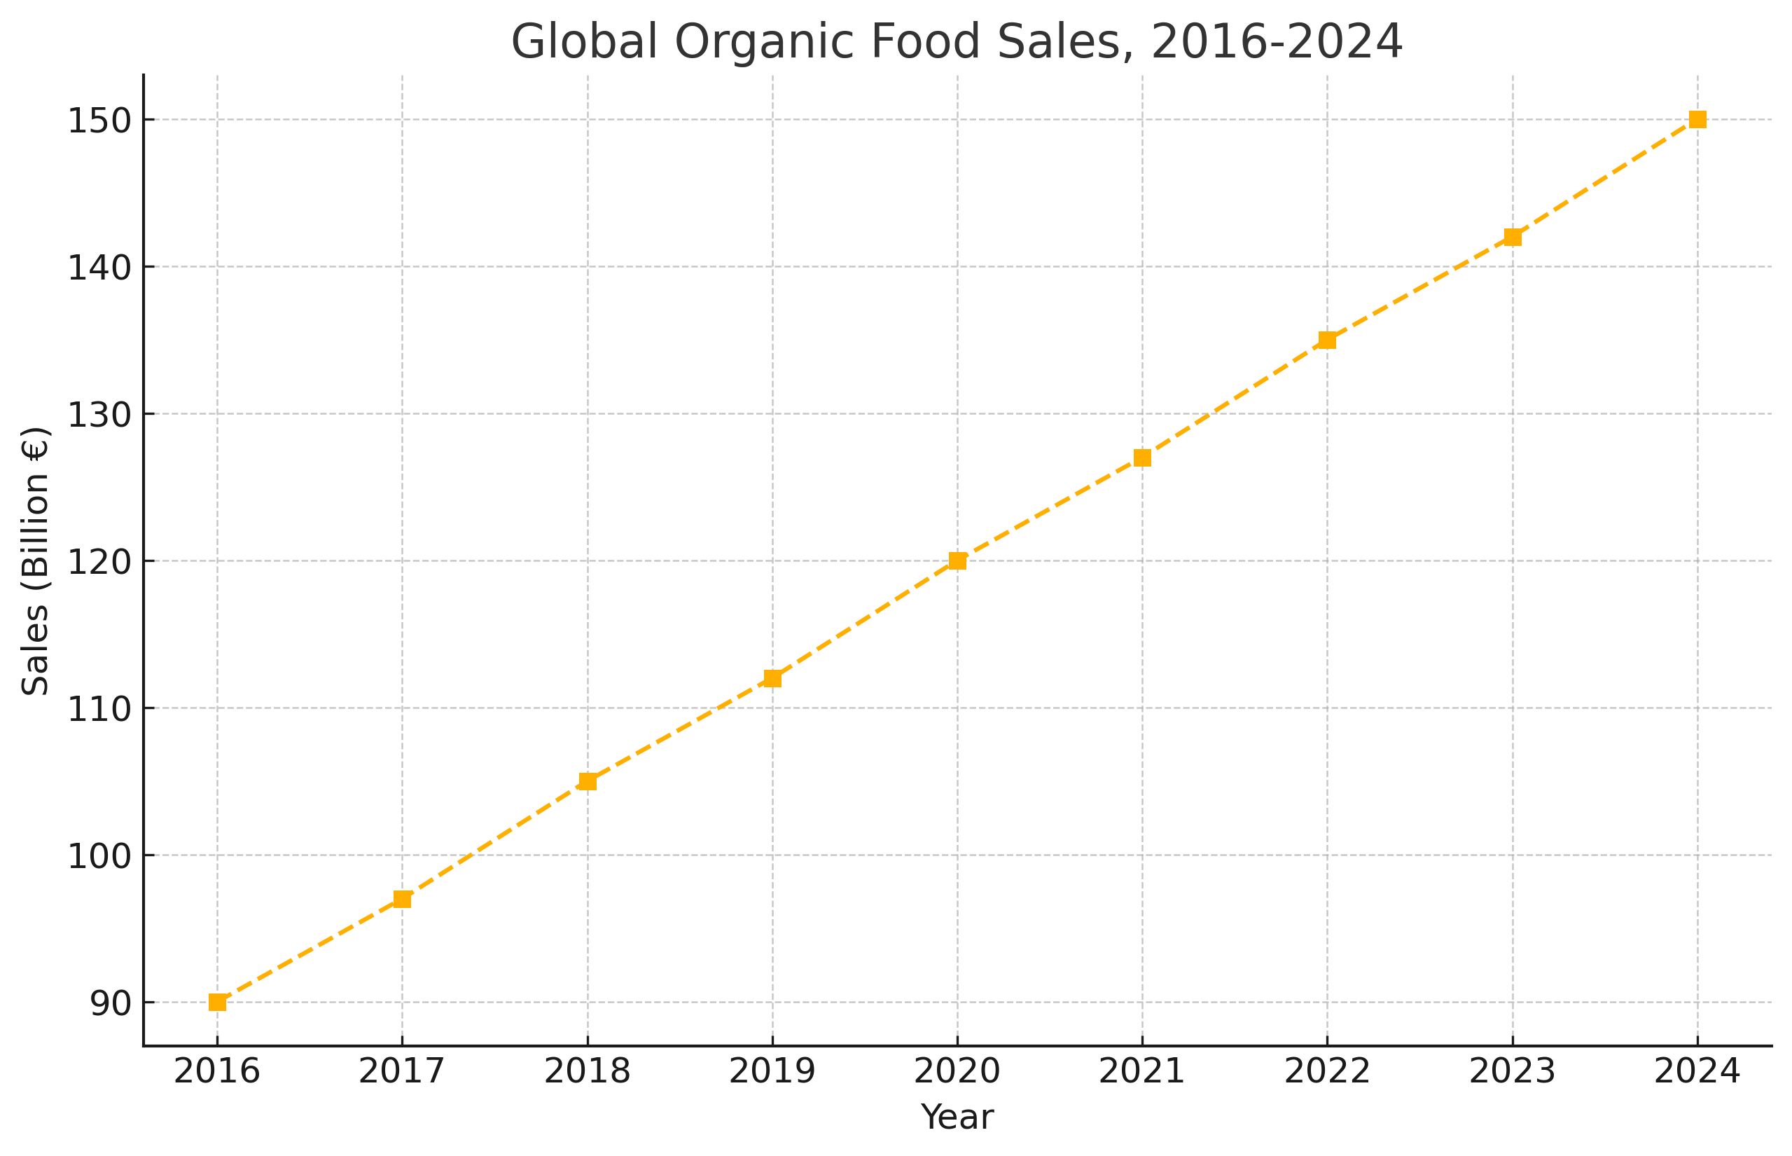

## **The Rise of Circular Economy Models**

The shift from linear “take-make-dispose” systems toward circular economy frameworks is accelerating. Companies such as **Grover** lead in electronics rental and refurbishment, extending product lifespans and reducing e-waste (<https://www.neste.com/en-us/news-and-insights/sustainability/sustainability-trends-of-2025>). In construction, the integration of recycled materials and passive-house design standards is becoming widespread, enabling the development of net-zero buildings that align with global decarbonization targets.

## Sustainable Business Practices

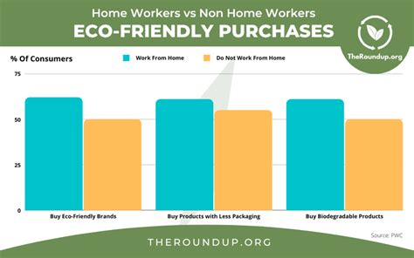

Corporate adoption of ESG criteria has become mainstream in 2025. Under the stewardship of **Ellen Jackowski**, **Mastercard** reduced supply-chain emissions substantially while sustaining revenue growth, demonstrating that profitability and planet-friendly operations can go hand in hand (<https://time.com/7172407/ellen-jackowski>). The voluntary carbon market is also expanding rapidly, reflecting intensified corporate commitments to net-zero targets and compliance with emerging climate policies (<https://www.itmustbenow.com/feature/uncategorized/ten-sustainability-trends-2025>).

## **Sustainable Living at Home**

Individual households are embracing eco-friendly practices at an unprecedented scale. Interior design trends favor natural and recycled materials—such as bamboo flooring and reclaimed wood furnishings—that enhance aesthetics while lowering environmental footprints (<https://www.thespruce.com/2025-sustainable-home-decor-trends-11712292>). Smart home systems and energy-efficient appliances allow occupants to monitor and curtail electricity use, and residential solar installations continue to proliferate, reducing dependence on centralized fossil-fuel power generation.

## **Future Outlook and Projections**

Looking forward, sustainable living is poised for further expansion, driven by escalating environmental pressures and evolving stakeholder expectations. Key projections include:

* A 50 percent rise in water demand in developing regions by 2025, reinforcing the need for advanced water-management infrastructures (<https://en.wikipedia.org/wiki/Water_scarcity>).
* Growth of the global circular economy market to USD 2.882 trillion by 2031, signaling broad adoption of resource-efficient business models (<https://impact.economist.com/sustainability/net-zero-and-energy/sustainability-trends-for-2025>).
* Continued expansion of green technology investments, with projected market valuation reaching USD 73.9 billion by 2030 (<https://www.globenewswire.com/news-release/2025/03/20/3046392/28124/en/Green-Technology-Sustainability-Market-Report-2025-Global-Green-Tech-Market-to-Skyrocket-to-73-9-Billion-by-2030-Driven-by-AI-ESG-Compliance.html>).

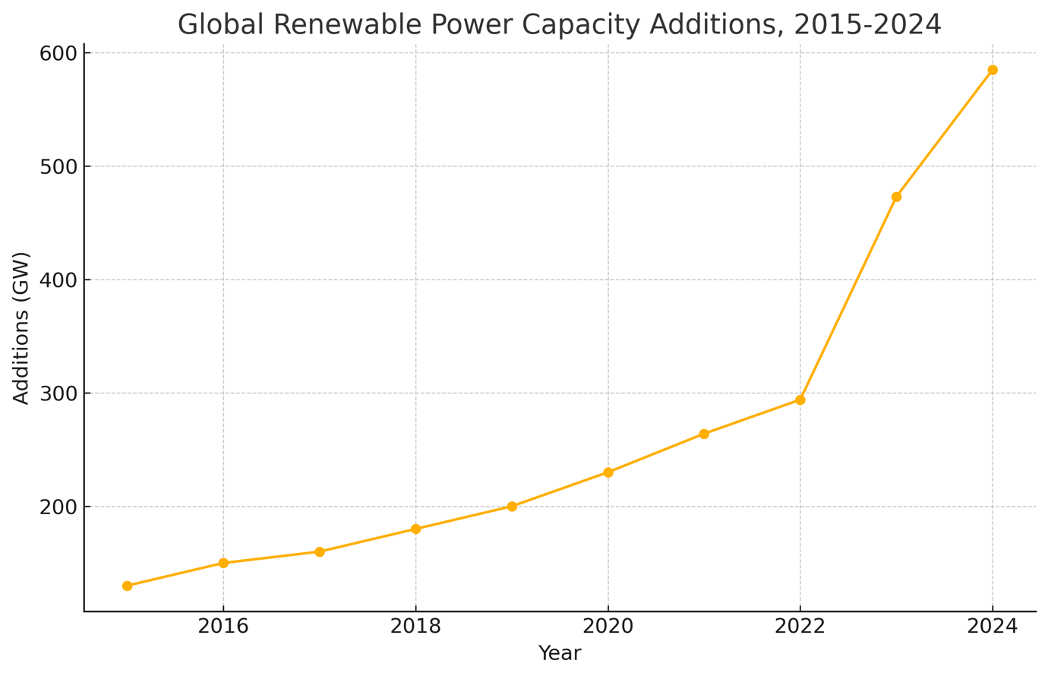

By aligning technological innovation, corporate governance, and consumer action, stakeholders worldwide can forge a more sustainable trajectory—ensuring resilient ecosystems, prosperous communities, and enduring economic vitality for generations to come.