**YouSaveOurWorld Whitepaper**

**Written by the Editorial team at YouSaveOurWorld**

**Date: April 2025**

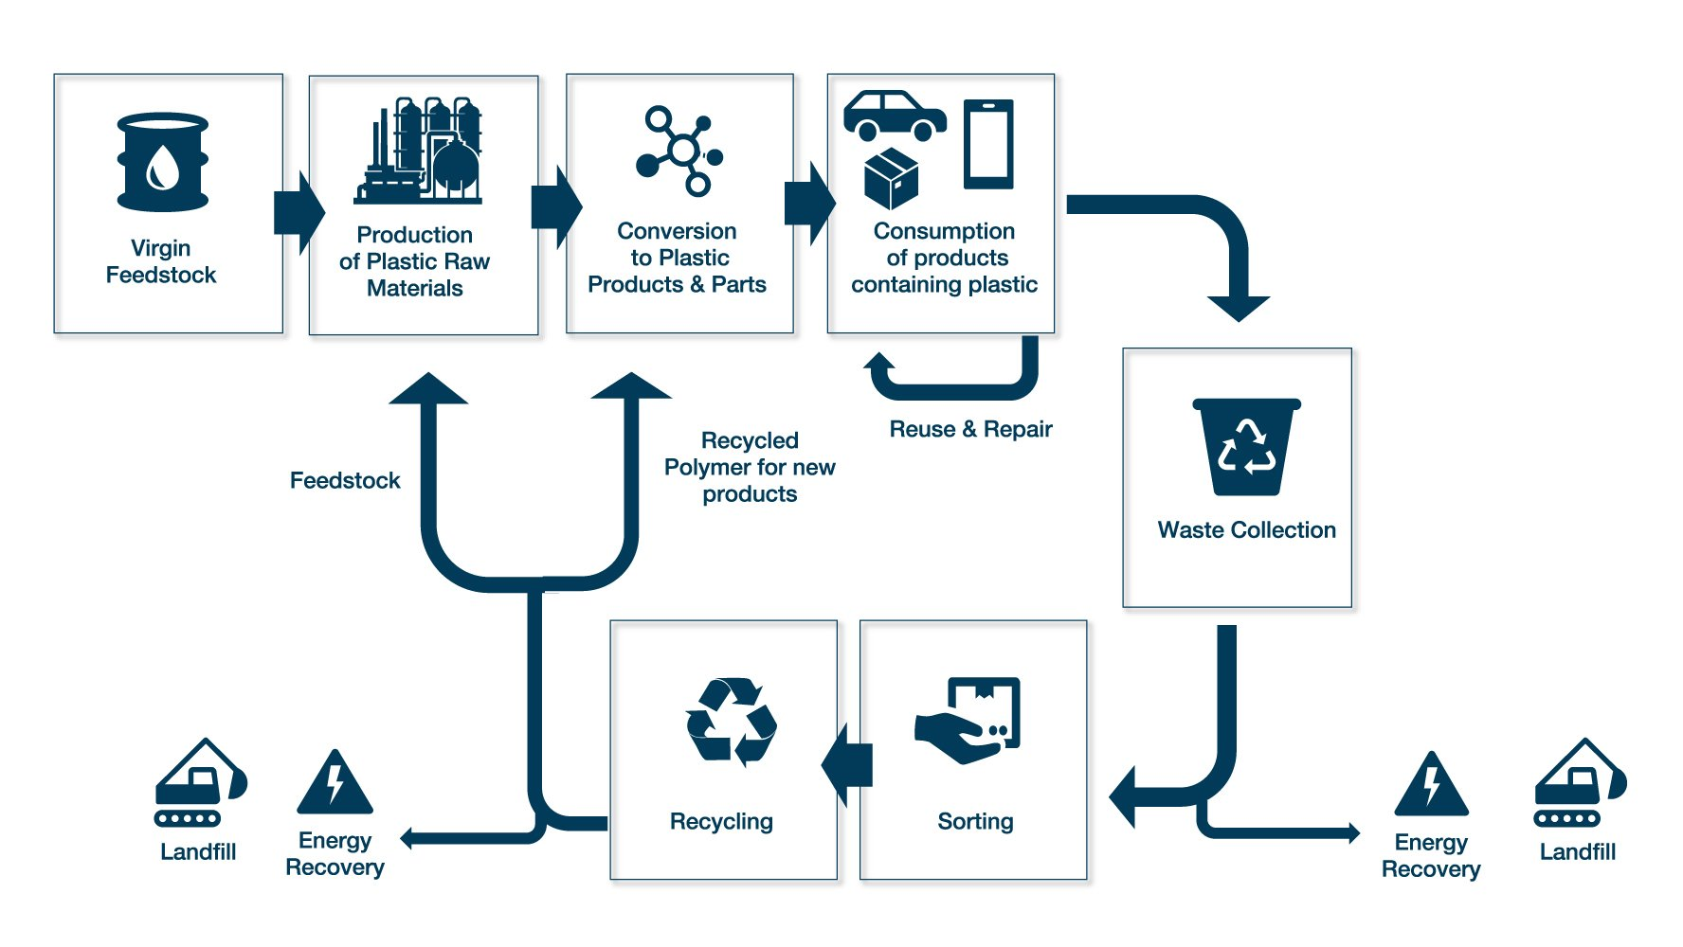

# **The State of Plastic Recycling in 2025: Global Trends and Regional Insights**

In 2025, plastic recycling stands at a pivotal crossroads. Decades of rising plastic production have culminated in a **global waste crisis** that challenges waste management systems on every continent. At **YouSaveOurWorld**, our mission is to empower with reliable information and foster collective action towards sustainability. This whitepaper provides an authoritative analysis of plastic recycling worldwide—examining current statistics, regional performances, and future forecasts—to illuminate where progress is being made and where critical gaps remain. Plastic pollution is now recognized as a **formidable environmental challenge**, and understanding the present state of recycling is essential for shaping effective solutions.

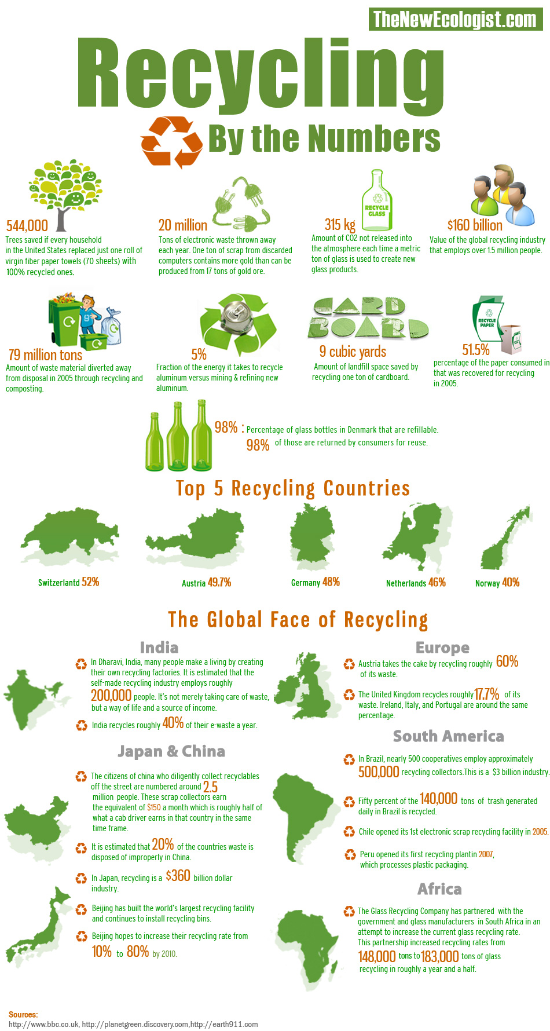

## Global Overview of Plastic Recycling (2025)

Worldwide plastic production and waste have reached unprecedented levels. According to Our World in Data (<https://ourworldindata.org/plastic-pollution>), the world now produces over **450 million tonnes of plastics annually**, a figure that has doubled since the beginning of the century. Yet **only about 9 percent of plastic waste is recycled globally**. The United Nations Environment Programme’s Global Plastics Outlook (<https://www.unep.org/resources/report/global-plastics-outlook>) confirms that roughly half of all plastic waste ends up in landfills, about one-fifth is incinerated, and the rest is **“mismanaged”**—dumped or leaked into the environment, fueling the pollution of oceans and landscapes.

Why is recycling lagging even as concern grows? One issue is that **new (“virgin”) plastic remains cheaper to produce than recycled plastic**, due to low fossil-fuel prices and economies of scale as highlighted by the OECD’s plastics analysis (<https://www.oecd.org/environment/plastics>). Contamination of waste (food residues, mixed materials) and the complexity of modern plastics (multilayer packaging, diverse additives) mean much plastic cannot be easily or economically recycled. As a result, most new plastic is still made from petrochemicals rather than recycled feedstock—only **9.5 percent of the 400 million tonnes of new plastic in 2022** was from recycled material. These sobering global trends echo the **linear disposable culture** our planet has followed for decades, and they set the stage for the regional snapshots that follow.

| **Region/Country** | **Approx. Recycling Rate** |
| --- | --- |
| **Global (average)** | ~9 percent |
| **United States** | ~5 percent |
| **Canada** | ~9 percent |
| **United Kingdom** | ~17 percent |
| **European Union (EU-27, packaging)** | 41 percent |
| **Germany (packaging)** | ~51 percent |
| **France (packaging)** | ~25 percent |
| **Sweden** | ~8 percent |
| **Switzerland** | ~9 percent |
| **China** | ~31 percent |
| **Japan (material only)** | ~25 percent |
| **Japan (incl. incineration)** | 87 percent |
| **South Korea** | ~27 percent |
| **Singapore** | ~6 percent |
| **Malaysia** | ~18 percent |
| **Australia** | ~14 percent |
| **New Zealand** | ~13 percent |
| **South Africa** | ~22 percent |
| **Brazil** | 25.6 percent |

## North America: United States and Canada

**United States**  
The United States is one of the world’s largest plastic-waste generators, yet its recycling rate is among the lowest in the developed world. Americans produced about **51 million tons of plastic waste in 2021**, and only around **5 percent** was recycled—an overwhelming 95 percent was landfilled, burned, or littered. A 2023 report in The Guardian (<https://www.theguardian.com/environment>) documents how China’s 2018 ban on plastic-waste imports led U.S. municipalities to divert recyclable plastics to landfills, underscoring that **recycling alone, without systemic changes, is insufficient**.

**Canada**  
Each year, Canadians discard roughly **3.3 million tonnes of plastic**, of which **only about 9 percent** is recycled. Canada’s “Zero Plastic Waste by 2030” goal and bans on certain single-use items have spurred action, yet domestic recycling infrastructure remains underdeveloped. The volume-based fee system and emerging extended-producer-responsibility programs aim to raise rates, but as of 2025, **Canada’s packaging recycling is near 20 percent**, far from the targets envisioned.

## Europe: High Performers and Systemic Nuances

Europe often leads in waste management. The EU-27 averaged a **41 percent recycling rate for plastic packaging in 2022** (Eurostat <https://ec.europa.eu/eurostat/statistics-explained/index.php/Packaging_waste_statistics>), up from 24 percent in 2005, driven by binding directives and investment. The EU’s circular economy framework (<https://ec.europa.eu/environment/circular-economy>) further emphasizes packaging redesign and recycled content targets. Yet performance varies:

* **Germany** recycles about **50–51 percent of plastic packaging**, thanks to its long-running Green Dot program and strict household source-separation culture.
* **Sweden** achieves only **8–10 percent material recycling**, incinerating **80 percent** of its plastic for energy, raising questions about true circularity.
* **Norway** boasts a **97 percent return rate for plastic beverage bottles** but recycles under 30 percent of all plastics, relying heavily on waste-to-energy.
* **France** recycled **25 percent of its packaging** in 2022, prompting new deposit schemes and mandates for recycled content.
* **Italy** collected over **1.05 million tonnes** of packaging for recycling in 2022 through Corepla, equating to roughly 45–50 percent recycling.
* **United Kingdom** claims **52 percent packaging recovery**, but the independent Big Plastic Count (2024) found material recycling closer to **17 percent**, highlighting the gap between collection and true reprocessing.

Industry data from Plastics Europe (<https://www.plasticseurope.org/en>) reveal that only **7 percent of recycled packaging** is converted into new packaging locally, underscoring losses in sorting and reprocessing. Europe’s experience demonstrates that **binding policy can drive recycling above 50 percent**, but material circularity remains constrained without simultaneous waste reduction.

## Asia: Divergent Paths in East and Southeast

**China**  
China reports a **31 percent plastic recycling rate** domestically, processing tens of millions of tonnes annually. Following its 2018 import ban, China has invested heavily in waste sorting and recycling industries, supporting its “zero landfill” ambitions.

**Japan**  
Japan advertises an **87 percent recycling rate**, but **62 percent** of that is **thermal recycling** (incineration with energy recovery). True material recycling stands at about **25 percent**. Citizens meticulously sort waste, and PET bottle collection exceeds 90 percent (<https://japan-forward.com/plastic-recycling-japan>), yet films and mixed plastics remain challenging.

**South Korea**  
South Korea’s official **73 percent recycling claim** was revised downward: Greenpeace East Asia (<https://www.greenpeace.org/eastasia>) and independent analyses place true material recycling at **27–30 percent**. South Korea’s volume-based waste fees and EPR schemes have driven collection, but market demand for recycled resin lags.

**Singapore**  
Singapore incinerates **94 percent** of its total waste in WtE plants, with only **5 percent of plastics recycled** (<https://www.reuters.com/world/asia-pacific>). Land scarcity mandates incineration over sorting, resulting in minimal circularity despite clean streets.

**Malaysia & Thailand**  
After surges in imported scrap post-China ban, **Malaysia** recycled **18 percent** of its domestic plastic waste in 2022, guided by its National Circular Economy Action Plan. **Thailand**, long criticized for ocean-bound plastic, now recycles in the teens percent and aims for full recyclability by 2027.

## Oceania: Australia and New Zealand

**Australia**  
Australia’s plastics recycling rate was **13.9 percent** in 2022—far below its 70 percent target (Australian Government report <https://www.dcceew.gov.au/environment/protection/waste/plastics-report>). Of 2.85 million tonnes generated, only ~412 000 tonnes were recovered, and ~396 000 tonnes actually reprocessed. The collapse of voluntary soft-plastics programs highlighted the need for mandated recycled content and EPR schemes.

**New Zealand**  
New Zealand recycles roughly **13 percent of its plastic waste**, relying on export markets until 2021. National bag bans and the Waste Minimisation Fund are improving infrastructure, but economies of scale remain a challenge. Community reuse initiatives—championed by groups like Break Free From Plastic ([https://www.breakfreefromplastic.org](https://www.breakfreefromplastic.org/))—are gaining traction.

## Africa: South Africa’s Leadership and Continental Challenges

**South Africa**  
South Africa recycles **21–22 percent** of its plastic consumption, among the highest on the continent. The formal sector, led by Plastics SA (<https://www.plasticsinfo.co.za>), works alongside an extensive informal network of waste pickers, supported by EPR regulations. Despite this, **80 percent of plastic** still goes to landfills.

**Rest of Africa**  
Most sub-Saharan countries recycle below **4 percent** of total waste. Over 30 nations have banned plastic bags, reducing thin-film pollution, and grassroots reuse traditions persist. The World Economic Forum (<https://www.weforum.org>) highlights how linking waste management improvements to economic development could unlock Africa’s recycling potential.

## South America: Brazil’s Surge and Regional Outlook

**Brazil**  
Brazil’s post-consumer plastic recycling rate soared to **25.6 percent** in 2022, up 46 percent since 2018 (Abiplast <https://abiplast.org.br>; S&P Global <https://www.spglobal.com>). The National Solid Waste Policy formalized waste-picker cooperatives, driving collection and processing. PET bottle recycling approaches **55 percent**, feeding domestic polyester production.

**Rest of South America**  
Argentina, Chile, and Colombia recycle **8–17 percent** of plastics, largely via informal collectors. Bag bans and emerging EPR pilots are advancing, and National Geographic (<https://www.nationalgeographic.com/environment/article/plastic-pollution>) spotlighting riverine plastic has spurred policy action across the continent.

## Future Outlook and Forecasts

* **Production vs. Capacity:** Without intervention, plastic production—currently ~400 million tonnes annually—could **double by 2040**, while recycling hovers near **10 percent**, risking an annual 300 million tonnes of unrecycled waste by 2030.
* **Technological Advances:** Chemical recycling and AI-driven sorting offer paths to recover mixed plastics, though energy demands and economics pose challenges.
* **Market Demand:** Mandates like the EU’s 25 percent recycled-content rule for bottles by 2025 are creating stable outlets for recyclate.
* **Global Plastics Treaty:** The U.N. Environment Assembly (<https://www.unep.org/unea>) is negotiating a binding plastics treaty, with the ambition to set global recycling targets and mobilize infrastructure funding.
* **Beyond Recycling:** Source reduction and reuse models—refillable packaging, deposit-return schemes—are essential complements.
* **Community Engagement:** Education campaigns and grassroots networks such as the Plastic Pollution Coalition (<https://www.plasticpollutioncoalition.org>) are vital for improving sorting quality and public accountability.

The Pew Charitable Trusts’ Breaking the Plastic Wave analysis (<https://www.pewtrusts.org/en/projects/plastics>) outlines an optimistic scenario: combining reduction, design improvements, and robust recycling could cut 80 percent of plastic pollution by 2040. However, doing so demands unprecedented global cooperation, technological innovation, and a shift toward a true circular economy.

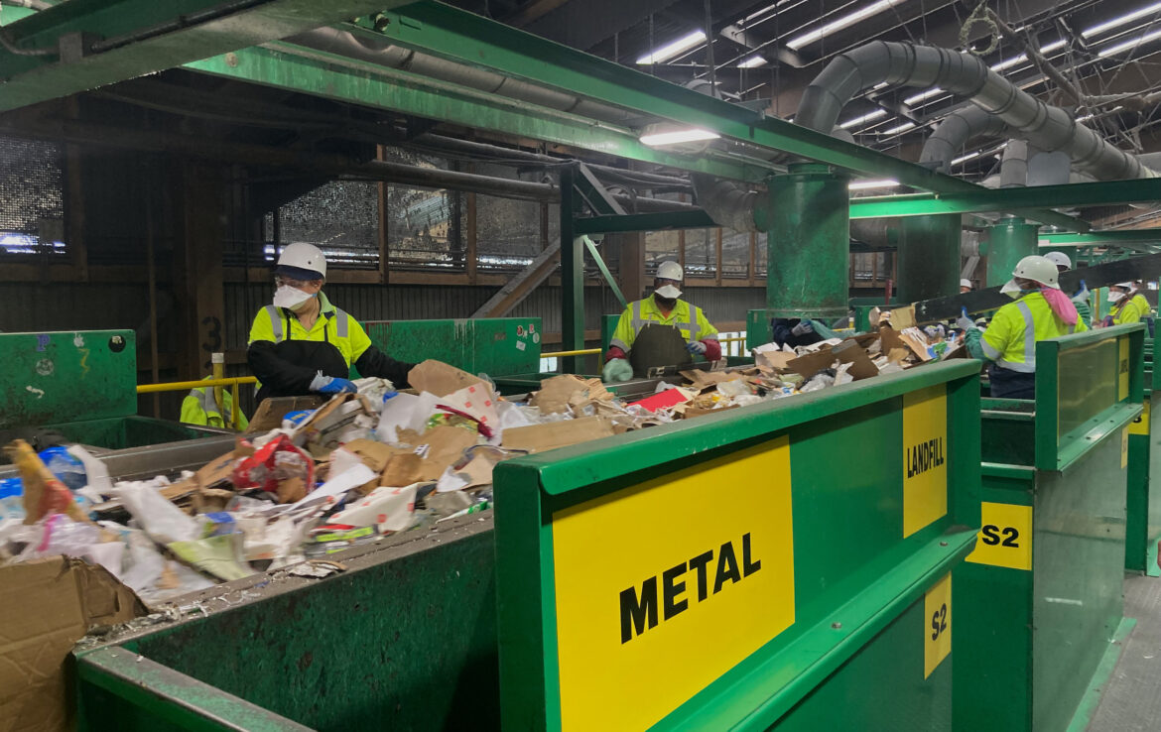

YouSaveOurWorld’s analysis underscores that **recycling is indispensable but insufficient alone**. A sustainable future for plastics requires integrated strategies—redesign, reuse, improved waste collection, and global policy alignment. As we move beyond 2025, the lessons and models highlighted here will guide policymakers, industry leaders, and civil society toward a more circular tomorrow.

Prepared by the YouSaveOurWorld Research Team, April 2025.