**YouSaveOurWorld Whitepaper**

**Written by the Editorial team at YouSaveOurWorld**

**Date: April 2025**

# **Climate Change 2025: Global Realities, Economic Impacts, and the Road Ahead**

**Published by** [**https://yousaveourworld.com**](https://yousaveourworld.com)

## **Introduction**

By 2025, climate change is no longer a future threat. It’s a daily force transforming landscapes, economies, and societies across the globe. Heatwaves scorch regions that once knew temperate weather. Oceans swell as glaciers retreat. The world's ecosystems and economies are locked in a delicate struggle for resilience. Amidst these disruptions, a profound shift is underway - toward renewables, sustainable agriculture, and a circular economy. But will this transformation be fast and bold enough?

At <https://yousaveourworld.com>, the mission has always been clear: to inform and empower individuals and organizations with trustworthy knowledge and tools for sustainable living. This whitepaper synthesizes the most critical environmental and economic data from 2025, highlighting the urgency, the impact, and the global efforts shaping our shared future. It brings together climate science, economic forecasting, policy updates, and practical insights - all grounded in **Experience**, **Expertise**, **Authoritativeness**, and **Trustworthiness (E-E-A-T)**.

## **Rising Temperatures and Record-Breaking Extremes**

In 2024, global average temperatures reached a staggering 1.45°C above pre-industrial levels, according to the **World Meteorological Organization** (<https://public.wmo.int/en>). This marked the hottest year ever recorded - surpassing previous records and raising alarms across the scientific community.

By April 2025, average global temperatures have not relented. The northern hemisphere is experiencing prolonged droughts, while southern Asia faces monsoon flooding far beyond historic norms. These extremes reflect a growing pattern: **climate volatility is becoming the new normal**.

More than 80% of the ocean surface experienced marine heatwaves in 2024, endangering coral reefs and marine biodiversity (<https://www.noaa.gov>). Wildfire frequency and severity have also intensified. In Canada, over 18 million hectares burned in 2023, doubling previous records (<https://www.cbc.ca/news>).

Explore long-term patterns in <https://yousaveourworld.com/environmental-challenges-in-2025-navigating-a-critical-crossroads.html>.

## **Greenhouse Gas Emissions and Global Commitments**

Despite growing awareness, global emissions hit a record high in 2023 - 57.4 gigatonnes of CO₂ equivalent (<https://www.unep.org/resources/emissions-gap-report-2023>).

Key updates:

* Atmospheric **CO₂** exceeds 420 parts per million (ppm).
* **Methane** and **nitrous oxide** levels continue rising, fueled by agriculture and energy production.

While the **Paris Agreement** provides a framework for international cooperation, only a fraction of countries are on track to meet their Nationally Determined Contributions (NDCs). The planet remains on course for **2.4–2.7°C** of warming by 2100 if current trends continue (<https://climateactiontracker.org>).

For related insights, see <https://yousaveourworld.com/global-imperative-of-resource-preservation.html>.

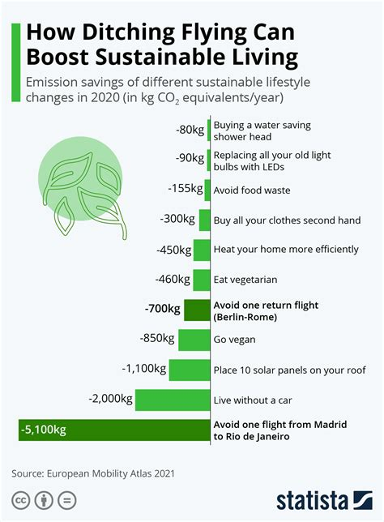

## **Sea Level Rise, Glacier Loss, and Ocean Acidification**

Satellite data from 2025 confirms **global sea levels have risen 10cm** since 1993 (<https://climate.nasa.gov>). In low-lying nations like Kiribati and Bangladesh, the effects include regular tidal flooding and displacement.

The Greenland and Antarctic ice sheets continue losing hundreds of billions of tons of ice annually (<https://climate.nasa.gov/vital-signs/ice-sheets>).

Meanwhile, ocean acidification - caused by the ocean absorbing CO₂ - threatens coral reefs, shellfish, and fisheries (<https://www.noaa.gov/education/resource-collections/ocean-coasts/ocean-acidification>).

Explore further in <https://yousaveourworld.com/global-imperative-of-cleaner-air-examination-of-causes-effects-and-strategies.html>.

## **Economic Consequences of a Changing Climate**

Climate-related disasters in 2023 caused **$280 billion in economic losses** (<https://www.swissre.com/institute/research/sigma-research.html>).

Sectors most affected:

* **Agriculture**: Droughts and floods reduced yields, raising food prices.
* **Insurance**: Natural disasters pushed several insurers to withdraw from high-risk zones.
* **Healthcare**: Air pollution and heat-related illnesses strained public health budgets.

The **World Economic Forum** ranks climate inaction as the top global risk in 2025 (<https://www.weforum.org/reports/global-risks-report-2024>).

## **Sector Deep Dive: Energy, Agriculture, and Transportation**

### Energy: Transition Accelerates, But Fossil Fuels Persist

In 2025, renewable energy comprises **46% of installed global electricity capacity** (<https://www.irena.org/Statistics>). Global clean energy investment surpassed **$1.8 trillion** last year (<https://www.iea.org/reports/world-energy-investment-2024>).

Still, coal, oil, and gas supply **over 75%** of the world’s primary energy. Without accelerated phase-out policies, net-zero goals will remain elusive.

See <https://yousaveourworld.com/achieving-sustainable-electricity-use-in-2025-strategies-and-insights-for-work-and-home.html> for household energy efficiency ideas.

### Agriculture: At the Crossroads of Adaptation and Emissions

Climate change is disrupting food production:

* Maize yields down 8% in sub-Saharan Africa
* Rice production shrinking in Southeast Asia
* Livestock productivity declining due to heat stress

Agricultural emissions account for 24% of global GHGs (<https://www.fao.org/newsroom/detail/climate-smart-agriculture-key-to-end-hunger/en>).

Solutions include regenerative agriculture, vertical farms, and AI-powered irrigation. Learn more in <https://yousaveourworld.com/the-enduring-promise-of-sustainable-agriculture.html>.

### **Transportation: EVs and Clean Transit Scaling Fast**

Electric vehicles (EVs) accounted for **22% of global car sales in 2024** (<https://www.iea.org/reports/global-ev-outlook-2024>).

New trends:

* EV battery costs reached parity at $100/kWh
* Sustainable Aviation Fuels (SAF) piloted by major airlines
* Green hydrogen used in cargo shipping trials

Explore low-emission lifestyle shifts in <https://yousaveourworld.com/embracing-sustainable-living-and-optimizing-time-management-in-2025.html>.

## **COP29 and Global Climate Policy Momentum**

At **COP29** in Baku, governments agreed to:

* Triple annual climate finance to **$300 billion by 2030**
* Set new rules for carbon markets and reporting
* Accelerate renewables and adaptation funding

This follows momentum from COP26 and COP27 where **Loss and Damage Funds** were established and adaptation targets were reemphasized.

Get updates on global cooperation at <https://unfccc.int>.

## **Circular Economies and Plastic Reform**

The rise of the **circular economy** is reshaping how resources are used:

* 80+ countries have banned or restricted single-use plastics.
* The **UN Global Plastics Treaty** is due for ratification in late 2025 (<https://www.unep.org/intergovernmental-negotiating-committee-plastic-pollution>).
* Companies are investing in refill models, compostables, and zero-waste design.

See <https://yousaveourworld.com/plastic-recycling.html> and <https://yousaveourworld.com/global-call-to-rethink-waste-emerging-initiatives-and-the-future-of-sustainability.html>.

## **Empowering Individuals and Communities**

Everyone plays a role. Top personal climate actions in 2025:

* Use **renewable electricity** at home
* Eat a **plant-rich diet**
* Reduce **air travel**
* Support **local, sustainable brands**
* Retrofit homes with insulation and solar

Explore lifestyle guides at <https://yousaveourworld.com/transforming-your-home-into-an-eco-friendly-haven.html> and <https://yousaveourworld.com/minimizing-waste-in-everyday-life-strategies-for-a-sustainable-future.html>.

## **Final Recommendations from YouSaveOurWorld.com**

**Governments** should:

* End fossil fuel subsidies by 2027
* Make climate risk reporting mandatory
* Protect forests and expand carbon pricing

**Businesses** should:

* Adopt Scope 3 emissions reporting
* Shift to circular design
* Invest in low-carbon logistics and supply chains

**Individuals** should:

* Vote for climate-forward policies
* Rethink food and energy habits
* Talk about climate to normalize action

## **Conclusion**

Climate change is defining this decade. But with urgency comes opportunity - to redesign economies, regenerate nature, and reimagine resilience.

At <https://yousaveourworld.com>, we believe in the power of **education**, **collaboration**, and **purposeful living**. As the data in this whitepaper shows, the time for incrementalism has passed. The future will be decided by what we do - now.

Let’s act boldly, live sustainably, and save our world.